**Closing Entries   
Profit or Loss Calculation**

**Closing Entries: The 4 Steps**

1. Close off **Income** accounts to Profit and Loss Summary account
2. Close off **Expense** accounts to Profit and Loss Summary account
3. Transfer the **Profit or Loss** from the Profit and Loss account to the Capital account.
4. Close off the **Drawings** account to the Capital account

**General Journal and Ledger examples:**

1. Close off **Income** accounts to Profit and Loss Summary account

Journal

Dr Sales / Fees

Interest income

Rent income

Discount received

Cr Profit & Loss Summary

Example

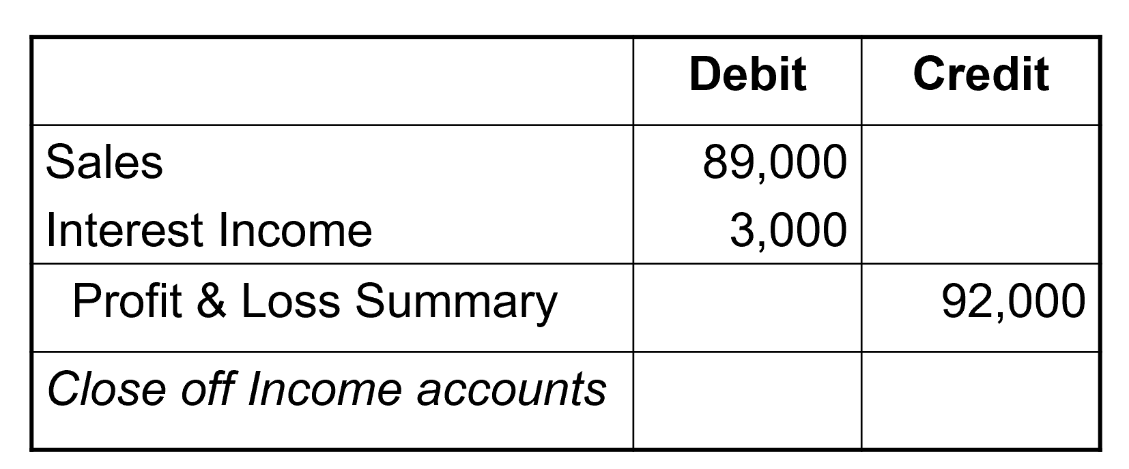

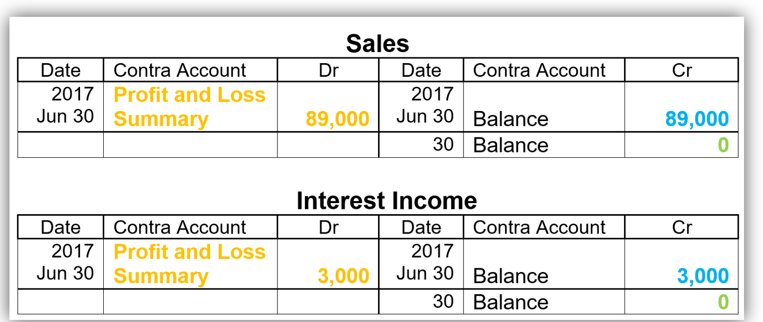

1. Close off **Expense** accounts to Profit and Loss Summary account

Dr Profit & Loss Summary

Cr Cost of sales

Wages

Stationery expense

Interest expense

Telephone

Rent expense

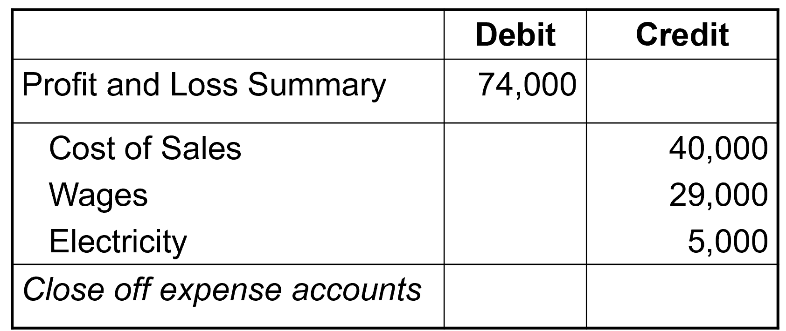

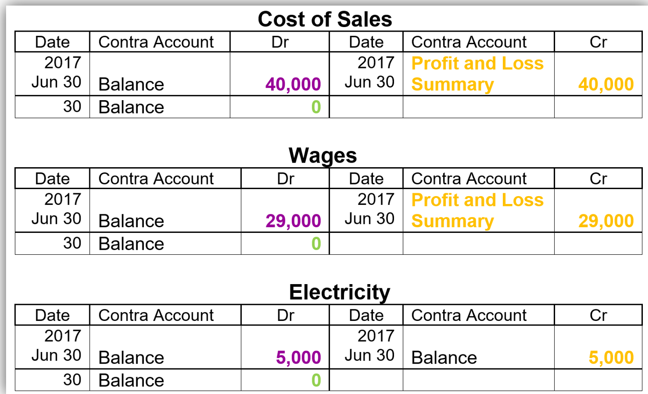

1. Transfer the **Profit or Loss** from the Profit and Loss account to the Capital account

Dr Profit & Loss Summary (if a profit)

Cr Capital

or

Dr Capital

Cr Profit & Loss Summary (if a loss)

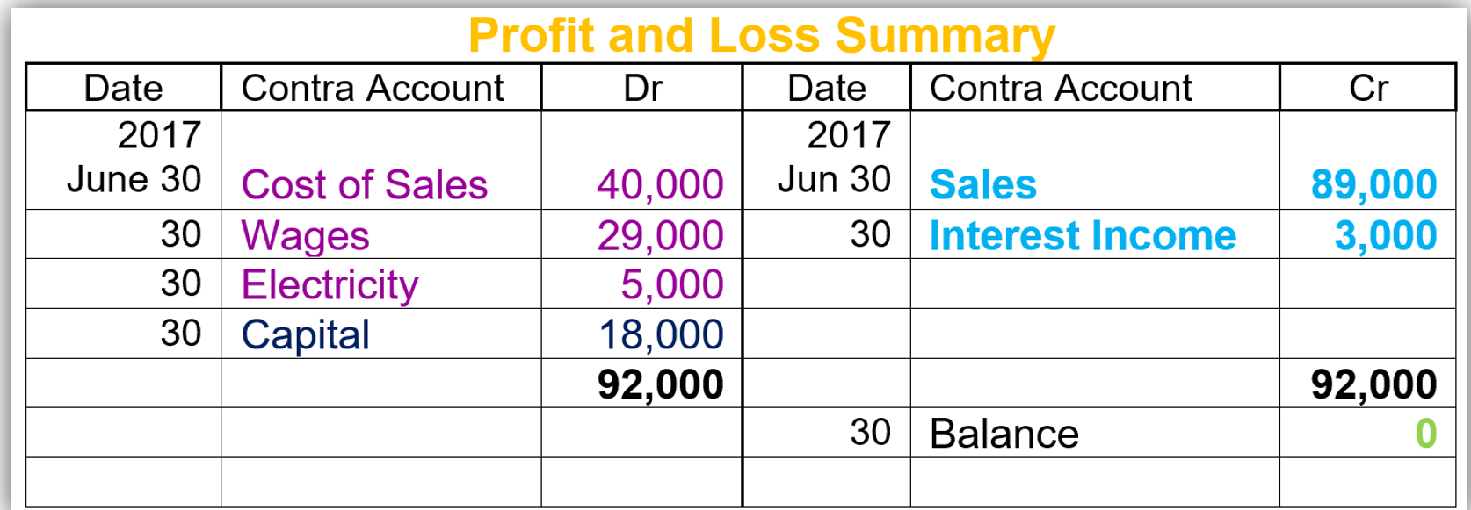

1. Close off the **Drawings** account to the Capital account

Dr Capital

Cr Drawings

